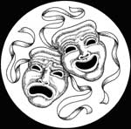
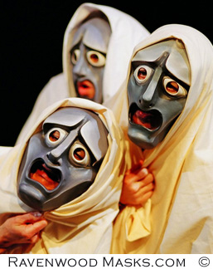
Greek Drama, and The Frogs of Aristophanes
Greek Plays
The theatre of Ancient Greece flourished between c. 550 and c. 220 BC. The polis of Athens, which was its centre, where it was part of a festival called the Dionysia, which honored the god Dionysus. Tragedy (any play with a sad ending, often a funeral), comedy (any play with a happy ending often a wedding), and the satyr play (“low brow” comedy with jokes, sex, pratfalls, etc.) were the three dramatic genres to emerge there. Western theatre originated in Athens and its drama has had a significant and sustained impact on Western culture as a whole.
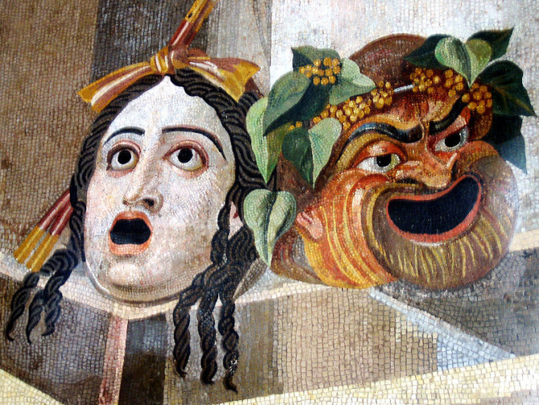
Until the 6th century BC, “acting” was not known – the closest examples were speakers who would memorize a speech and announce it from a stage. They always appeared as themselves, however, never “in character.” In 532 BC, the first recorded actor appeared on stage, giving lines as if he was someone other than himself. His name was Thespis, and this gives us the term “Thespian.”

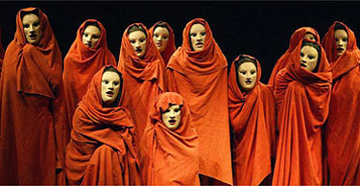
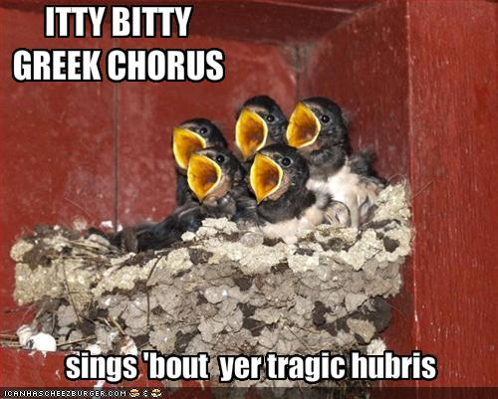
Greek Plays featured several actors, always wearing masks (above). These masks has exaggerated features to show the audience if the character was happy, sad, angry, etc., so no “acting” was needed – the actors just shouted their lines through the large mouth holes. Behind the actors was the “Greek Chrous” (below) of about a dozen actors/dancers, who would add emphasis to the play by interpreting the action through dance, chanting, or repeating the important lines. Their job was to interact with the audience AND the actors, to “stir the pot” and function as dramatic narrators for the action on stage.

Greek Theatres
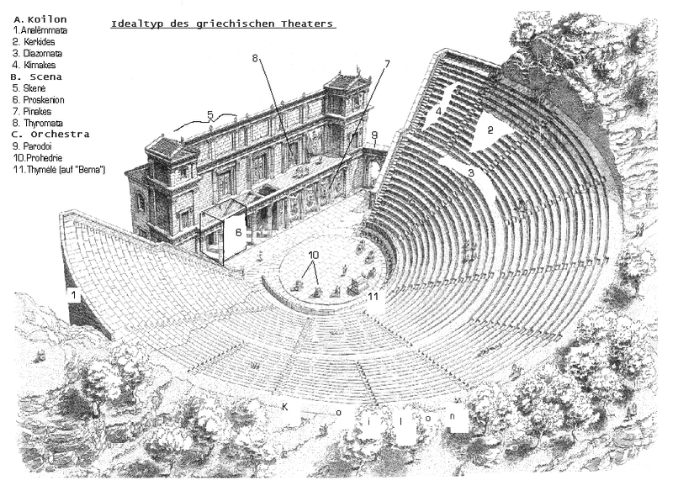
Greek Theatres were known as Odeons, and were always built on a flat area at the foot of a hill. Steps would be carved into the hill to provide seats, and the natural acoustics were excellent. The Greeks understood the science of sound very well, and ancient Odeons did not need microphones in order for the audience to hear.

Behind the stage was a wall known as a skene (gives us the word “scene”) which was a simple wall which could be painted to supply a backdrop. All deaths occurred behind this wall where the audience could hear, but not see, the deaths, as this was considered inappropriate at that time.

Above the stage was a mechane (machine), a crane which could be used to make an actor fly, lower props onto the stage, etc. Usually, a Greek play ended when all hope was lost, everyone was close to death or already dead, and an actor playing a God was lowered onto the stage to magically put everything to rights, revive dead characters, create peace in the world, etc. This gives us the phrase Deus ex Machina, one of the worst actions any playwright or film writing can commit today.
Deus ex Machina can be found in the end of Lord of the Flies, Donnie Darko, and War of the Worlds. J.K. Rowling has been accused of resorting to it. It is common in many non-procedural crime shows, like Castle or Murder She Wrote.

Disney animated films have traditionally resolved devastating problems using a deus ex machina, such as an inexplicable survival of bodily trauma found in Tangled.

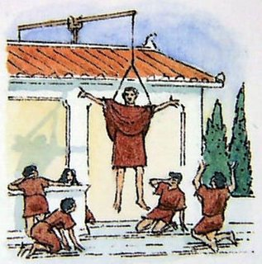
Often, writers will make intentional reference to it - in The Simpsons episode Thank God, It's Doomsday, Homer ascends to Heaven and realizes the rest of his family is still enduring the apocalypse, so God agrees to put off the apocalypse and cries, "Deus ex machina!", returning everything to normal.
In the television special, Olive, the Other Reindeer, Olive is locked in the back of the mail carrier's truck, she finds a package addressed to her from "Deus Ex Machina." The package is a metal file she uses to escape. In the film Dodgeball: A True Underdog Story, at the film's climax, a chest is brought in bearing the phrase "Deus Ex Machina", following a plot twist of the like. In the film Adaptation, the main character seeks screen writing advice from a veteran of the film industry, and is advised, "Find an ending, but don't cheat, and don't you dare bring in a deus ex machina." A deus ex machina is later employed in the film when the main character is held at gunpoint and is about to be killed, but out of nowhere an alligator attacks the villain and saves the main character's life.
Greek Playwrights
Aeschylus (555-425 BC) is considered the father of drama, as he was the first to write plays with more than one actor, which allowed both the first dialogue and the first acting between two or more people. After fighting in the Battle of Marathon, he wrote Prometheus Bound, in the old style – it is a long monologue told by an actor playing the character of Prometheus, who is chained to a rock. After this, he wrote the world’s first dialogue and the world’s first trilogy, the three play set The Orestia, which tells of the downfall of the House of Atreus, including the tragedies Agamemnon, Electra, and The Eumenides.
Sophocles (497-404 BC) is regarded as the father of tragedy. His plays focus on the struggle between good and evil, choice and fate, heroes and villains, and many consider him to be the greatest writer of Greek tragedy. Otherwise perfect heroes suffering from Hubris are common. He wrote Antigone and Oedipus Rex.
Euripides (480-406) is seen as the first playwright to add complexity to his characters. Unlike Sophocles, Euripides wrote about heroes who were not perfect – his flawed protagonists are common in literature today. He never idealized Gods or Heroes, instead showing them with all their flaws. This paved the way for later playwrights to actually make fun of them. The Bacchae is his most famous work.
Aristophanes (446-386 BC) is the first comic playwright, and thus the father of comedy. Basing his work on Euripides, Aristophanes wrote plays which lampooned Gods, heroes, and politicians using low brow jokes, toilet humor, and puns. He invented (or made common) giving someone the middle finger as an insult. He was often accused of being immoral, but is seen today as a brilliant wit.
The Frogs
Aristophanes’ most famous play is The Frogs. In it, Dionysius, the God of Plays, wishes to enjoy the comic plays of Euripides. The only problem is that Euripides has been dead for years, and Dionysius is bored of the old ones. So, with the aid of his slave Xanthias, Dionysius sets out for Hades (Hell) to bring Euripides back to Earth so he can continue to write. He asks Hercules for directions before setting off.
Frogs Questions
1- Each of the major Greek playwrights are important for different reasons. What are they?
2- What is the play “The Frogs” about?
3-What type of play is The Frogs?
4-Why is the play considered good, and what would an audience like about it?
5-What type of humor is used in the first page? What are the jokes?
6-The God Dionysius is the God of plays. He is also a character in this play. He has a servant named Xanthias – what is Xanthias complaining about at the start of the play, and what does Dionysius say to him?
7- Dionysius speaks with Hercules, and tells him he has a just read a play, and he wants to bring the writer of that play back to life. What is the play and the author, and what does Dionysius compare his desire to?
8-To bring someone back to life, Dionysius must travel to Hades (the afterlife) and bring back their soul. Hercules asks why Dionysius would bring back Euripides instead of Sophocles. What does Dionysius say?
9 – How would you describe the concept of Deus ex Machina?
10 – Give an example of this concept you have seen or read.

